
- Code: N352-1L012FLAM
Upper : Leather Lining : Leather Sole : PU (Polyurethane) Accessories : Buckle Heel Type : ANATOMIC

RUBIK - L012Beige

Upper - Leather
Lining -Leather
Midsole - PU(polyurethane)
Sole - PU(polyurethane)
Accessories - Buckle
Heel Type - Flat Anatomic

Upper - Leather
Lining -Leather
Midsole - PU(polyurethane)
Sole - PU(polyurethane)
Accessories - Buckle
Heel Type - Flat Anatomic

Upper - Leather
Lining -Leather
Midsole - PU(polyurethane)
Sole - PU(polyurethane)
Accessories - Buckle
Heel Type - Flat Anatomic
Upper : Leather Lining : Leather Sole : PU (Polyurethane) Accessories : Buckle Heel Type : ANATOMIC
RUBIK- ORCHIDE
- Code: N352-1L012ORCH
Upper : Leather Lining : Leather Sole : PU (Polyurethane) Accessories : Buckle Heel Type : ANATOMIC
RUBIK-YELLOW

Upper - Leather
Lining -Leather
Midsole - PU(polyurethane)
Sole - PU(polyurethane)
Accessories - Buckle
Heel Type - Flat Anatomic

Upper - Leather
Lining -Leather
Midsole - PU(polyurethane)
Sole - PU(polyurethane)
Accessories - Buckle
Heel Type - Flat Anatomic
Upper : Leather Lining : Leather Sole : PU (Polyurethane) Accessories : Buckle Heel Type : ANATOMIC

Upper - Leather
Lining -Leather
Midsole - PU(polyurethane)
Sole - PU(polyurethane)
Accessories - Buckle
Heel Type - Flat Anatomic
RUBIK- BLUE
- Code: N352-1L012BLUE
Upper : Leather Lining : Leather Sole : PU (Polyurethane) Accessories : Buckle Heel Type : ANATOMIC
RUBIK-GREEN
RUBIK-DARK RED
RUBIK - L012Pastel Pink

Upper - Leather
Lining -Leather
Midsole - PU(polyurethane)
Sole - PU(polyurethane)
Accessories - Buckle
Heel Type - Flat Anatomic
Upper : Leather Lining : Leather Sole : PU (Polyurethane) Accessories : Buckle Heel Type : ANATOMIC
RUBIK - L012Purple

Upper - Leather
Lining -Leather
Midsole - PU(polyurethane)
Sole - PU(polyurethane)
Accessories - Buckle
Heel Type - Flat Anatomic
Upper : Leather Lining : Leather Sole : PU (Polyurethane) Accessories : Buckle Heel Type : ANATOMIC

Upper - Leather
Lining -Leather
Midsole - PU(polyurethane)
Sole - PU(polyurethane)
Accessories - Buckle
Heel Type - Flat Anatomic
RUBIK-TURQOISE
ZOE-FLAME
RUBIK - L012Turqoise

Upper - Leather
Lining -Leather
Midsole - PU(polyurethane)
Sole - PU(polyurethane)
Accessories - Buckle
Heel Type - Flat Anatomic
RUBIK - L012White

Upper - Leather
Lining -Leather
Midsole - PU(polyurethane)
Sole - PU(polyurethane)
Accessories - Buckle
Heel Type - Flat Anatomic
ZOE - 1L011

ZOE-BLUE

- Code: N402-2L005WHIT
Upper : Leather Lining : Leather Sole : PU (Polyurethane) Accessories : Buckle Heel Type : ANATOMIC

NOMAD-White
SLIPPERS – NEXA- ORCHIDE

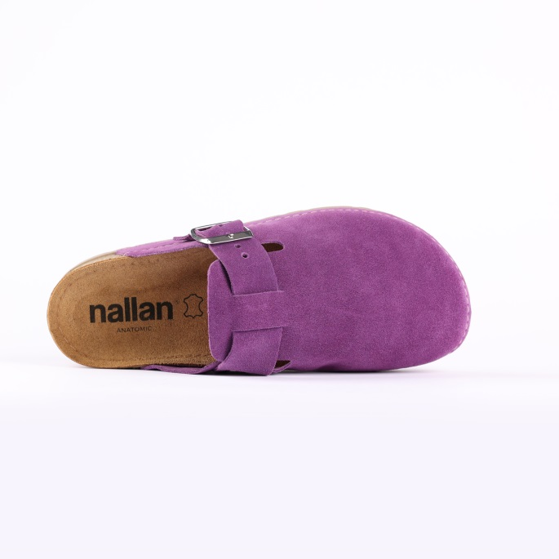
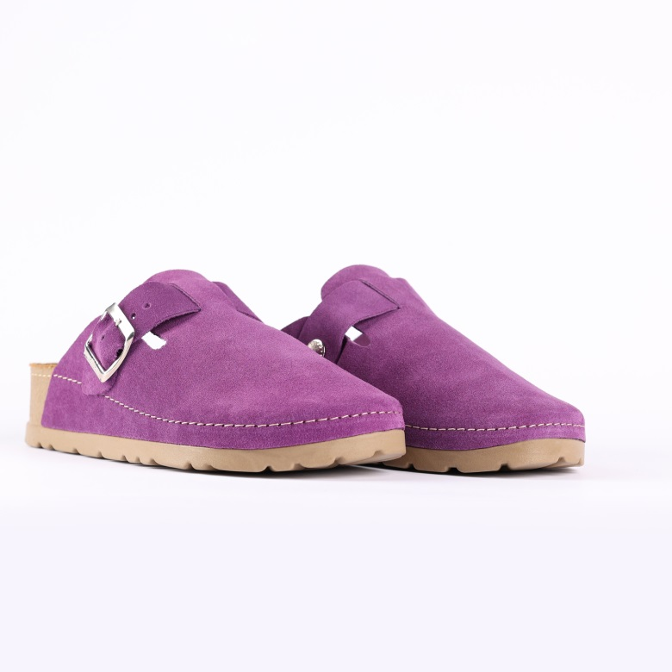

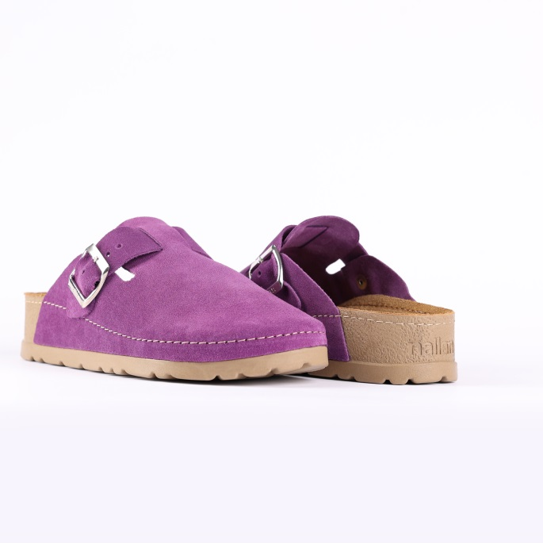

Code: N355-1V071ORCH
Upper : Velour
Lining : Leather Sole : PU (Polyurethane) Accessories : Yes Heel Type : Anatomic

SIZE: 36-42 41-46
44
4

SLIPPERS – NEXA- RED

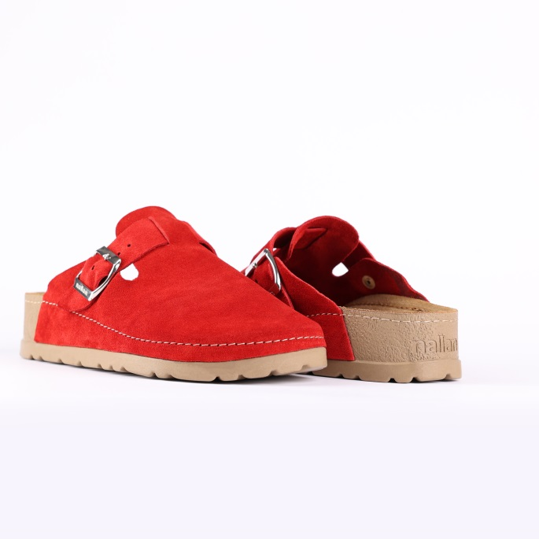
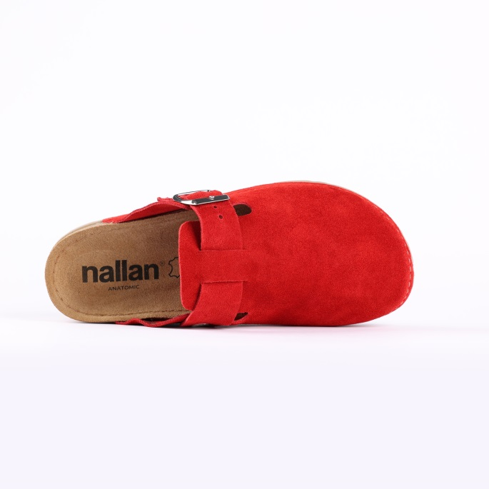
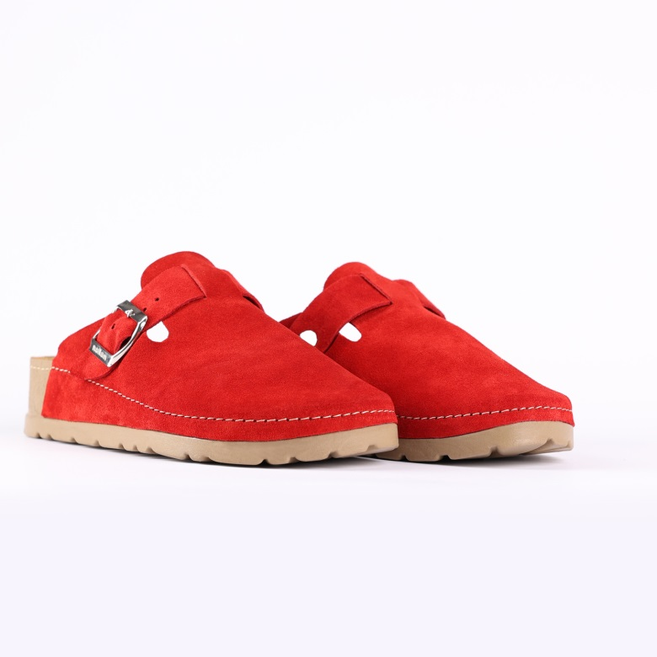

Code: N355-1V071RED0
Upper : Velour
Lining : Leather Sole : PU (Polyurethane) Accessories : Yes Heel Type : Anatomic

SIZE: 36-42 41-46
44
4

SIZE:37-42

SLIPPERS – NEXA- PINK

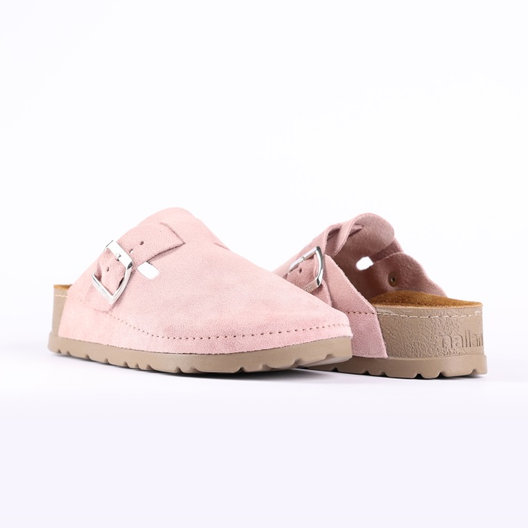
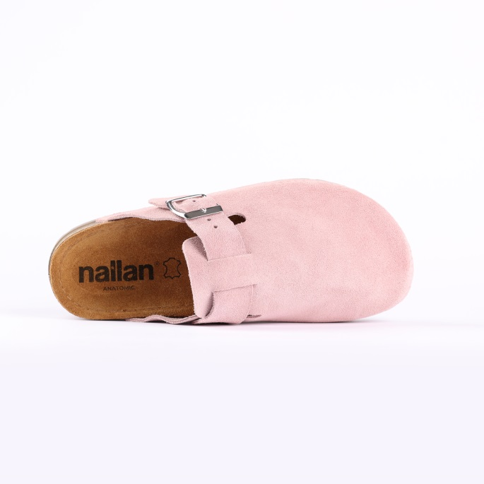
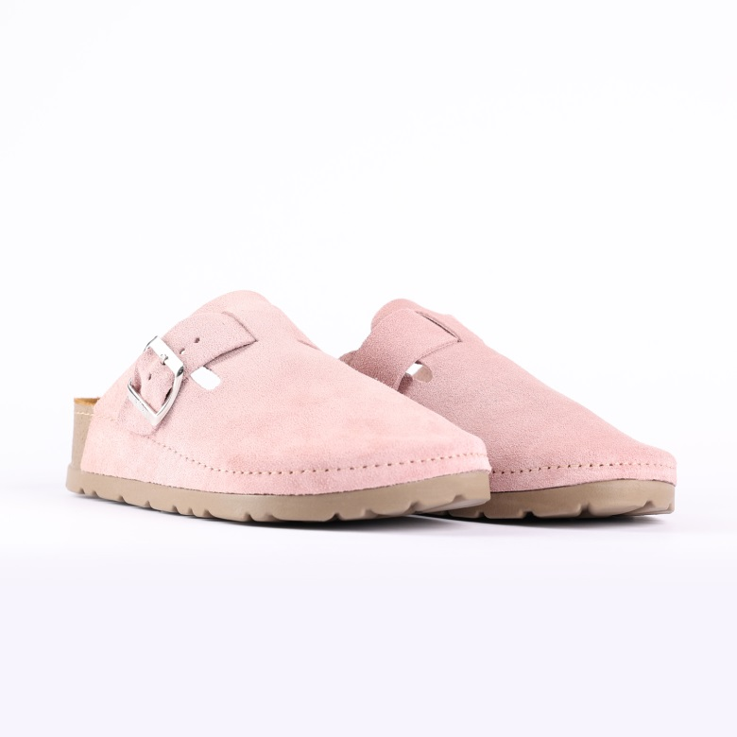

Code: N355-1V071PINK
Upper : Velour
Lining : Leather Sole : PU (Polyurethane) Accessories : Yes Heel Type : Anatomic

- Code:

SIZE: 36-42 41-46
44
4

SLIPPERS – NEXA-LILAC

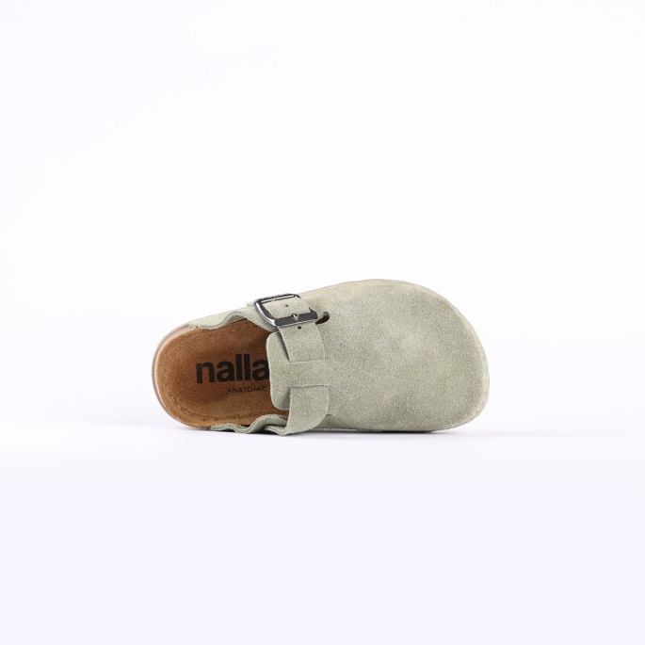

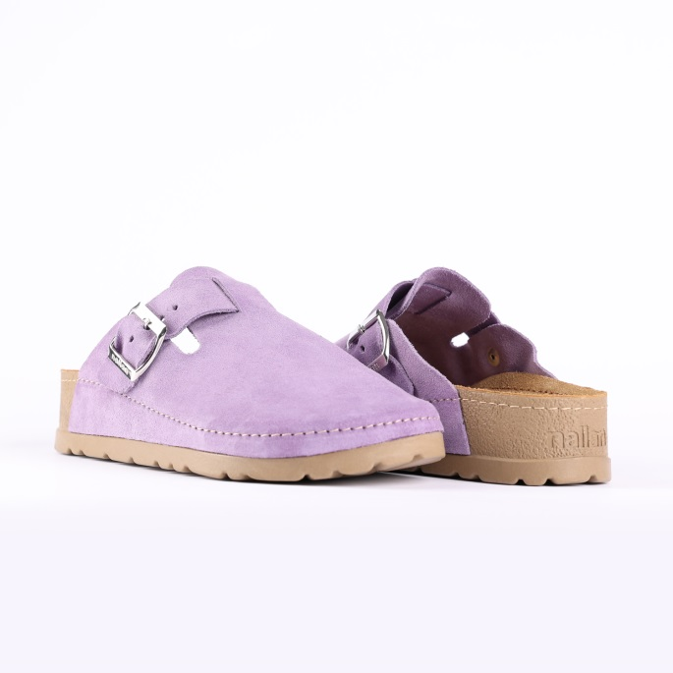
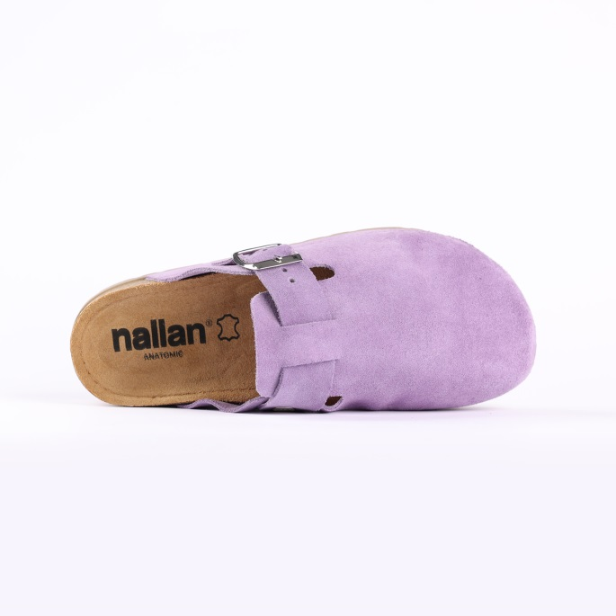
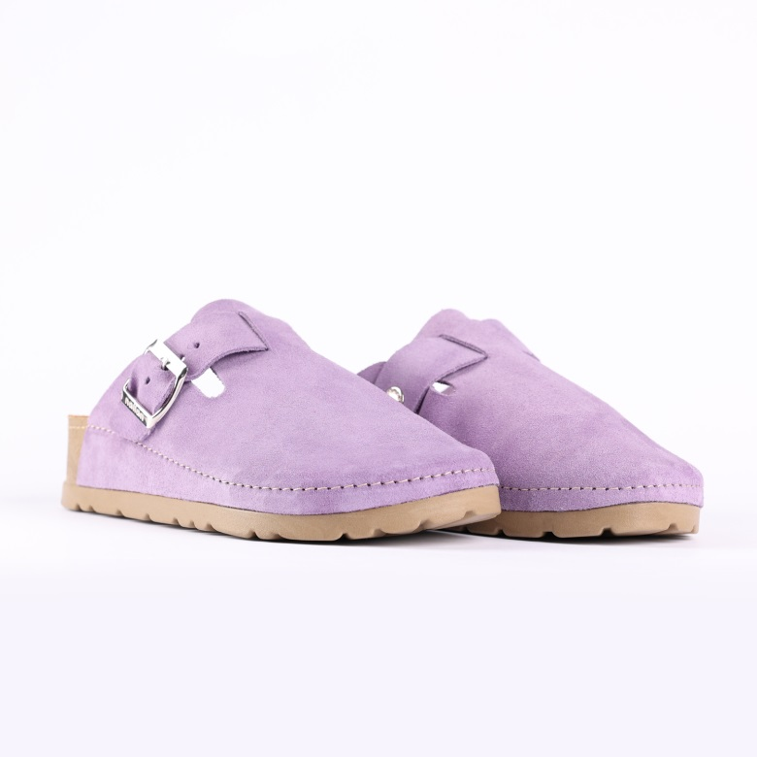

Code: N355-1V071LILA
Upper : Velour
Lining : Leather Sole : PU (Polyurethane) Accessories : Yes Heel Type : Anatomic

SIZE: 36-42 41-46
44
4

SLIPPERS – NEXA- DARK ROSE

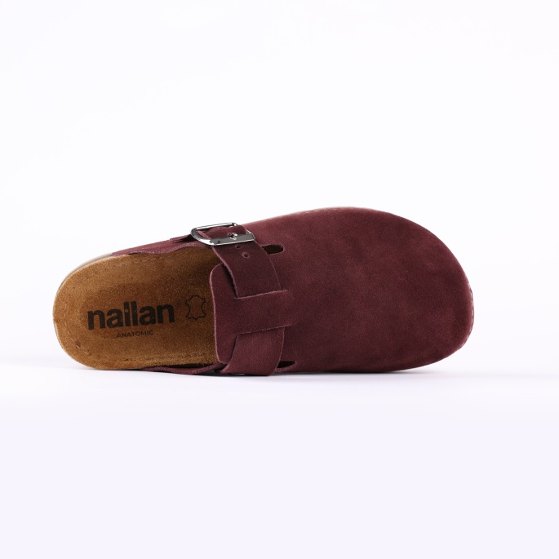
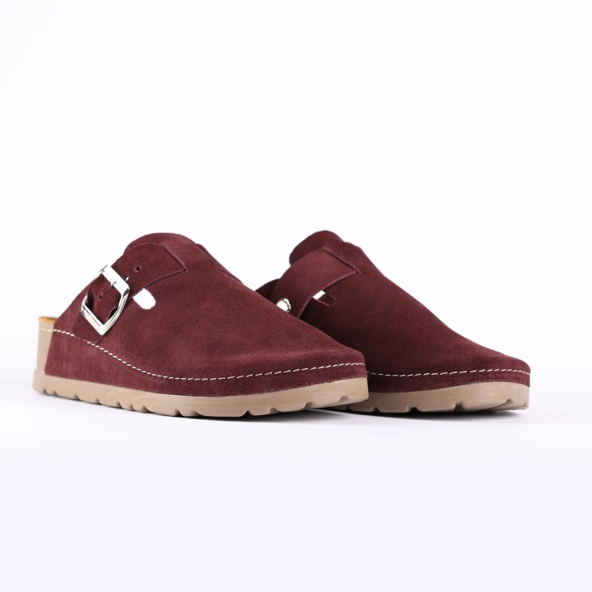

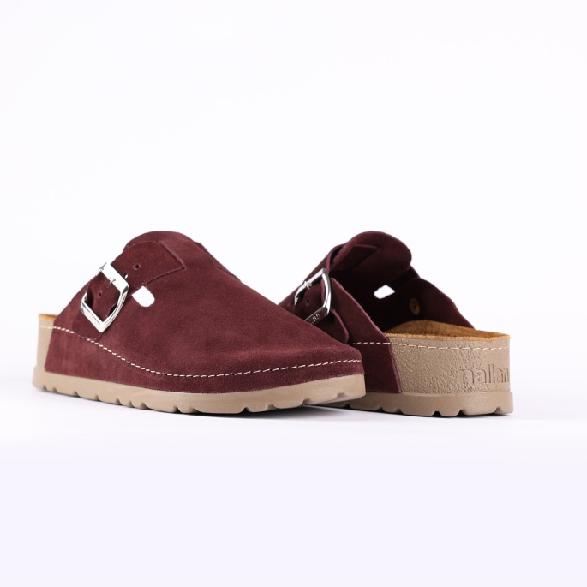

Code: N355-1V071DROS
Upper : Velour
Lining : Leather Sole : PU (Polyurethane) Accessories : Yes Heel Type : Anatomic

SIZE: 36-42 41-46
44
4

SLIPPERS – NEXA- ROSE BISQUE

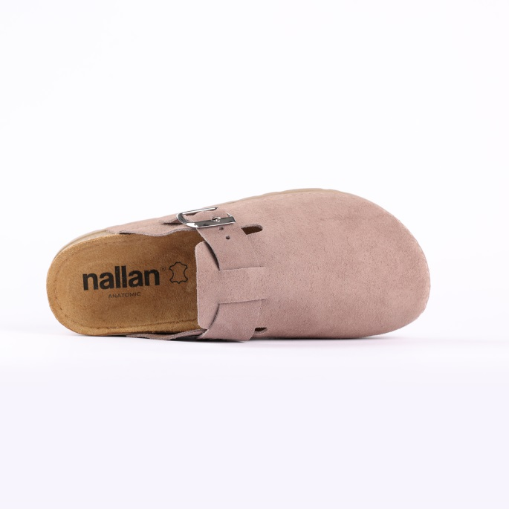
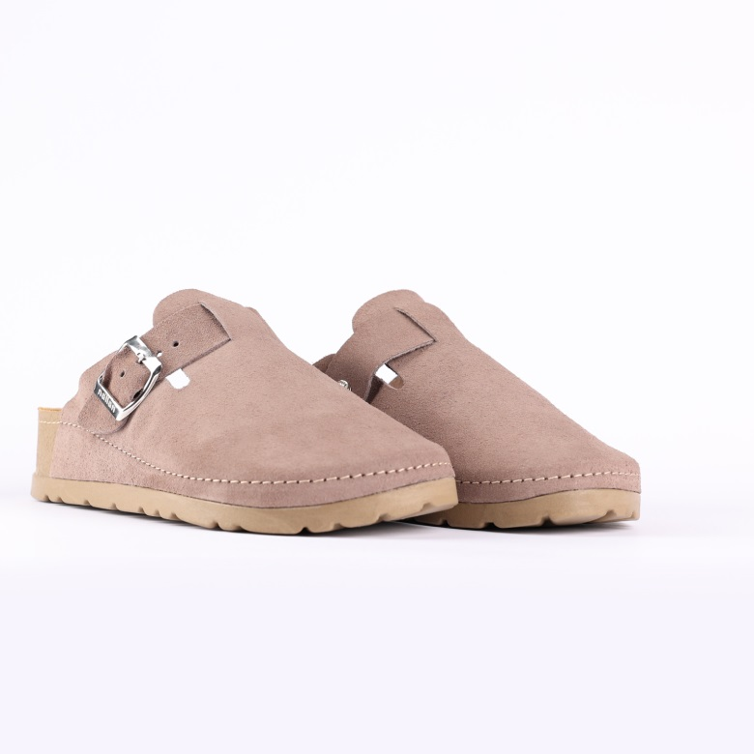

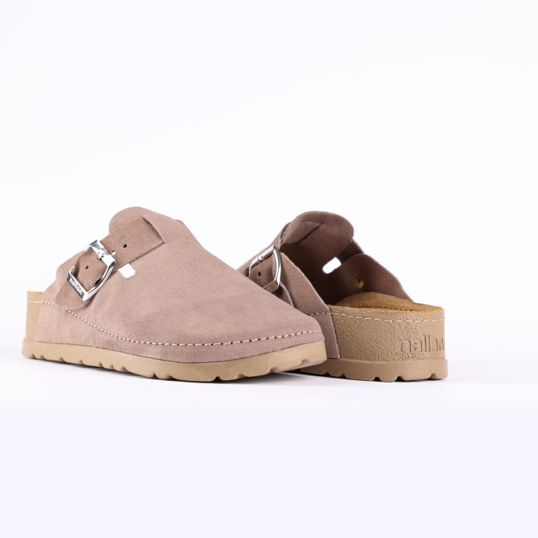

Code: N355-1V071RBIS
Upper : Velour
Lining : Leather Sole : PU (Polyurethane) Accessories : Yes Heel Type : Anatomic

SIZE: 36-42 41-46
44
4

SLIPPERS – NEXA- BLACK GREEN

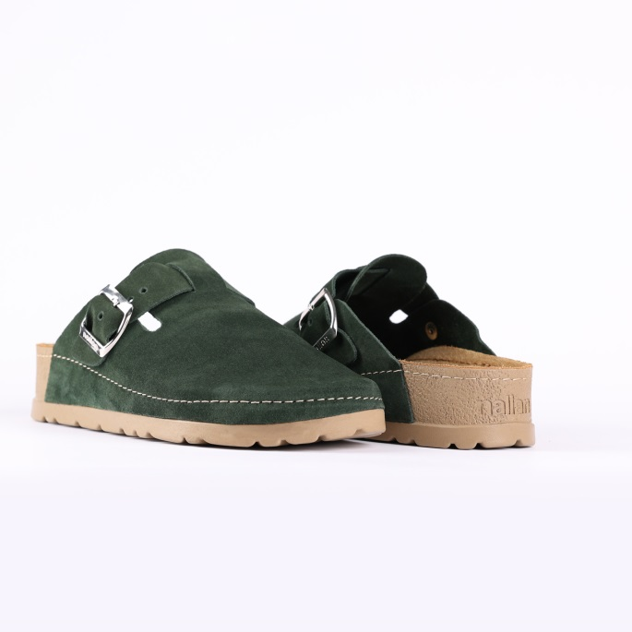
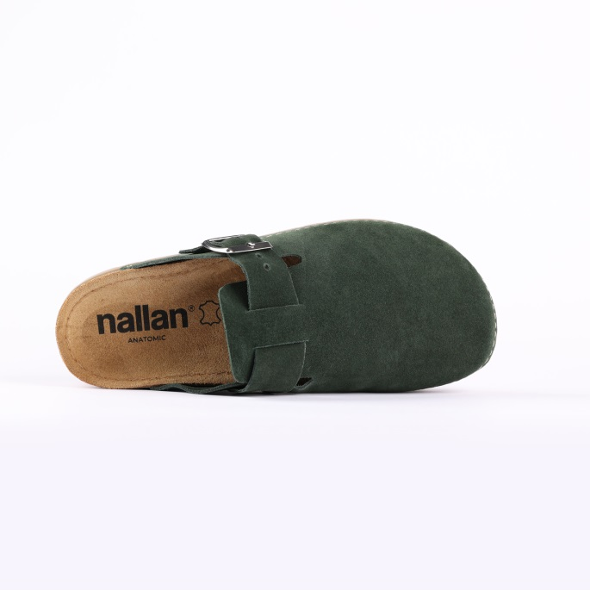
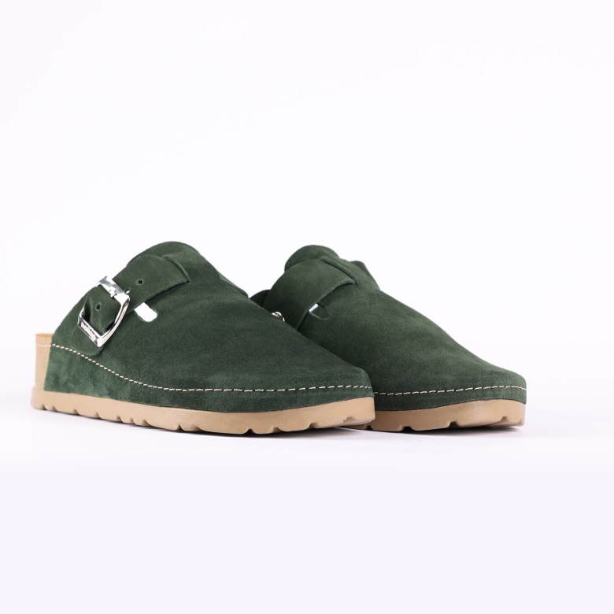

Code: N355-1V071BGRE
Upper : Velour
Lining : Leather Sole : PU (Polyurethane) Accessories : Yes Heel Type : Anatomic

SIZE: 36-42 41-46
44
4

SLIPPERS – NEXA-PECAN

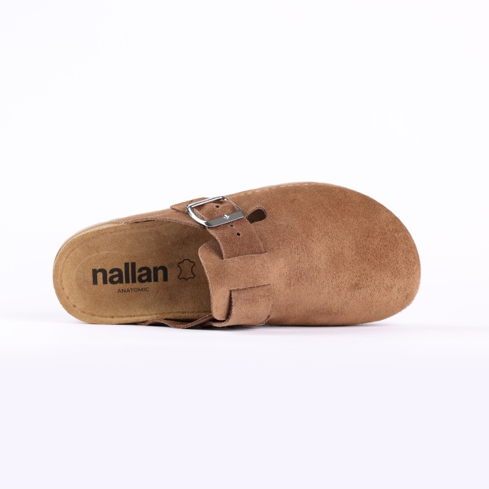
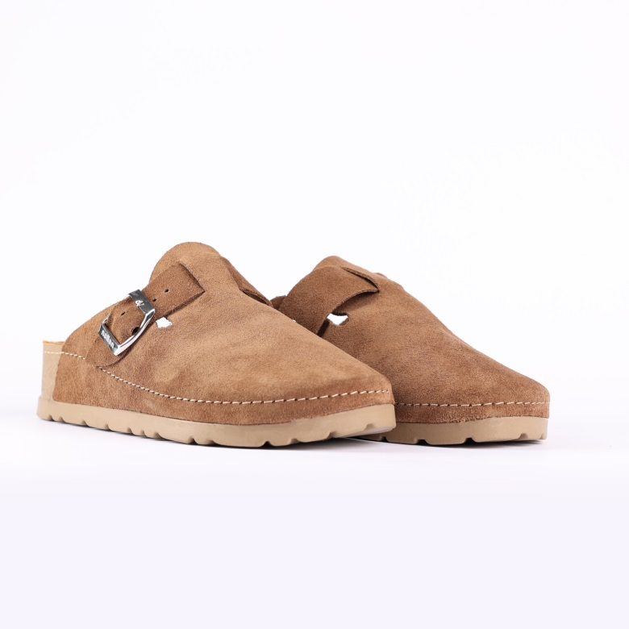

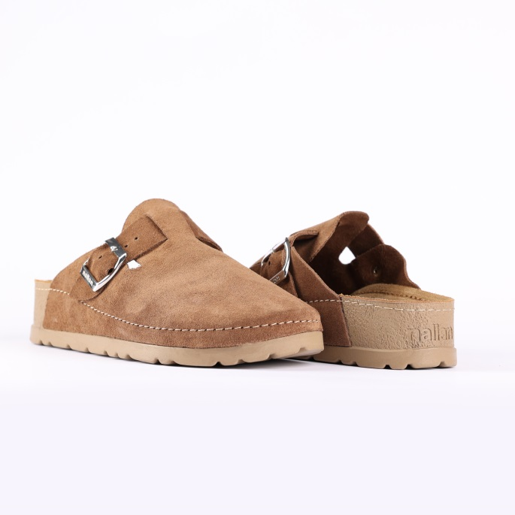

Code: N355-1V071PECA
Upper : Velour
Lining : Leather Sole : PU (Polyurethane) Accessories : Yes Heel Type : Anatomic

SIZE: 36-42 41-46
44
4

SLIPPERS – NEXA- DEMITASSE

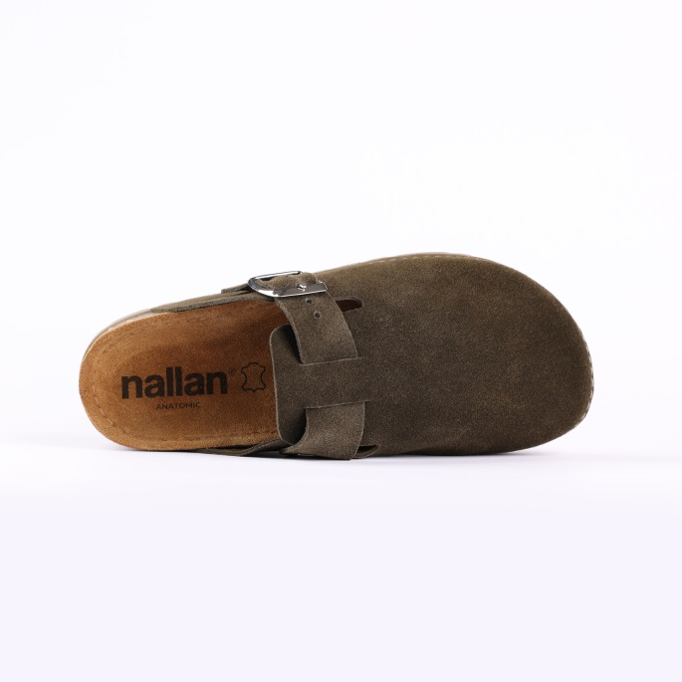
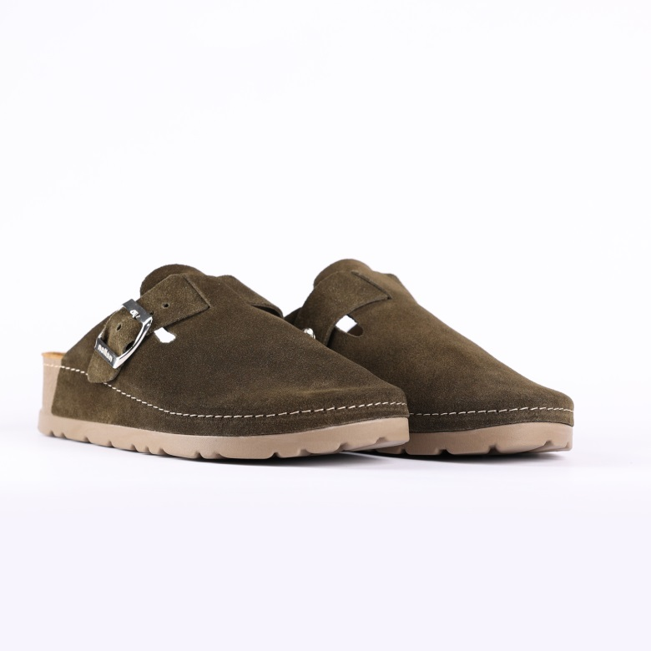
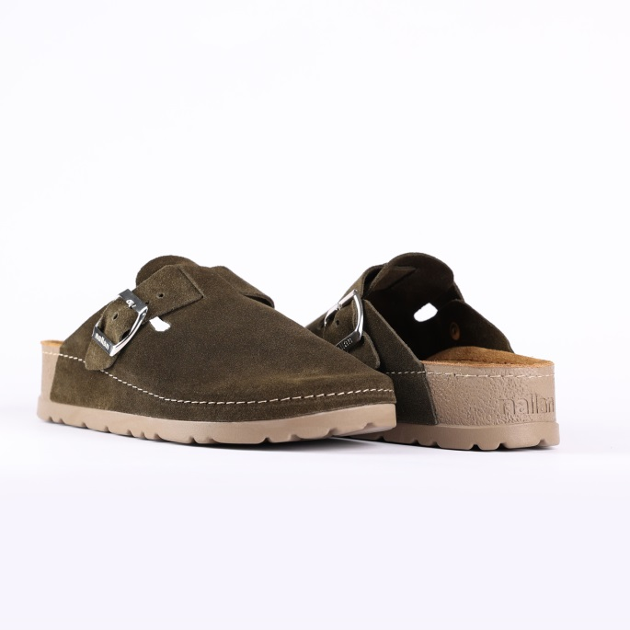

- Code: N355-1V071DEMI
Upper : Velour
Lining : Leather Sole : PU (Polyurethane) Accessories : Yes Heel Type : Anatomic

SIZE: 36-42 41-46
44
4

SLIPPERS – NEXA- YALE

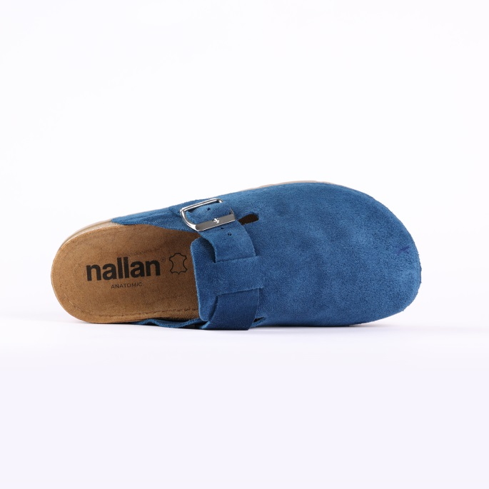
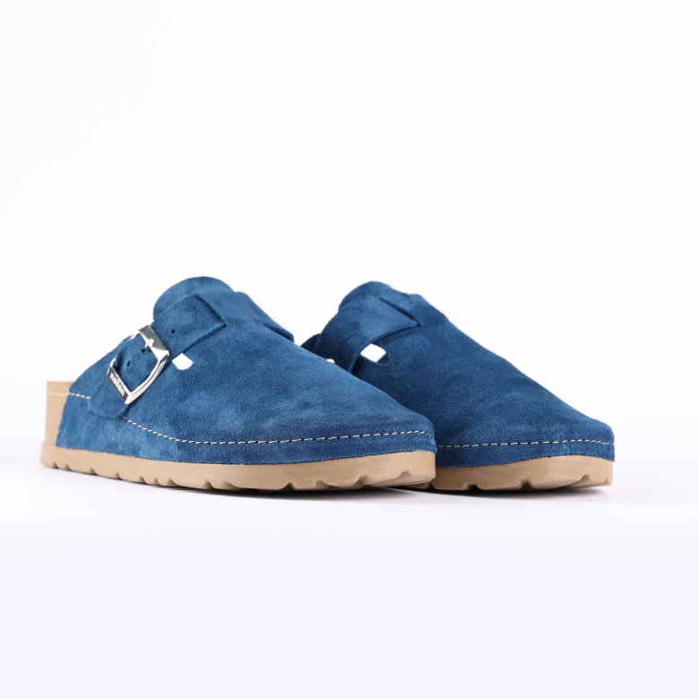
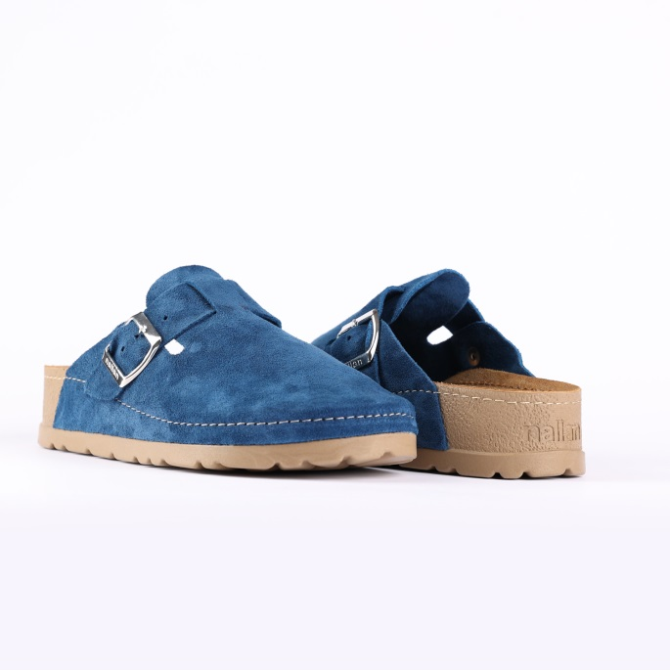

- Code: N355-1V071YALE
Upper : Velour
Lining : Leather Sole : PU (Polyurethane) Accessories : Yes Heel Type : Anatomic

SIZE: 36-42 41-46
44
4

SLIPPERS – NEXA- ACORN

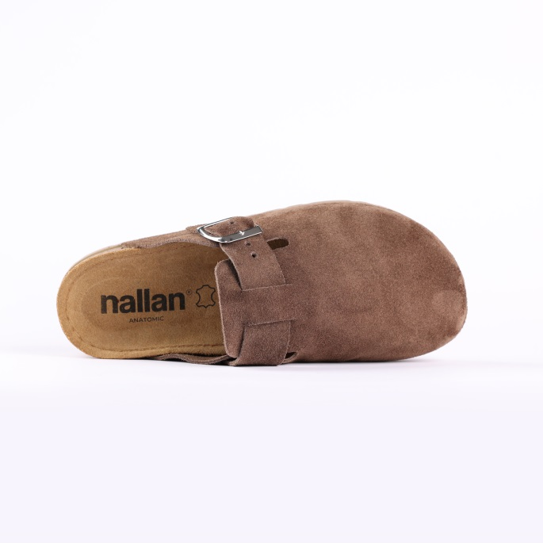

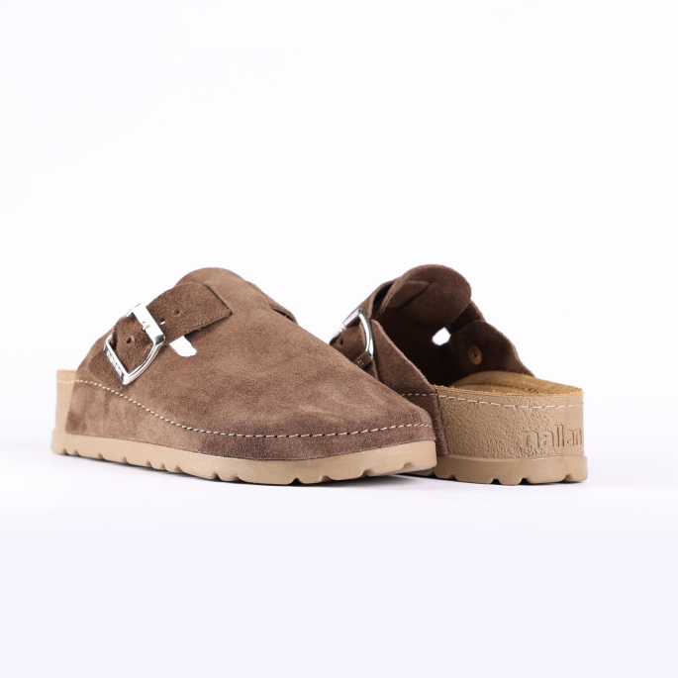
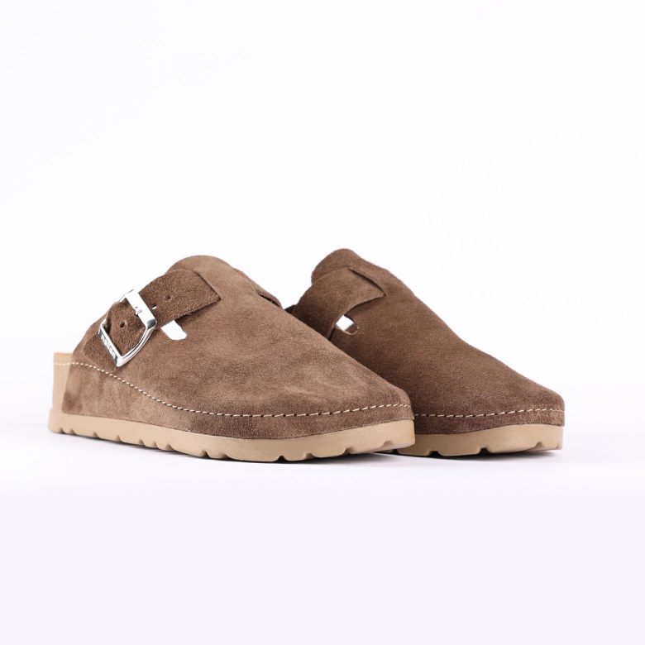

- Code: N355-1V071ACOR
Upper : Velour
Lining : Leather Sole : PU (Polyurethane) Accessories : Yes Heel Type : Anatomic

SIZE: 36-42 41-46
44
4

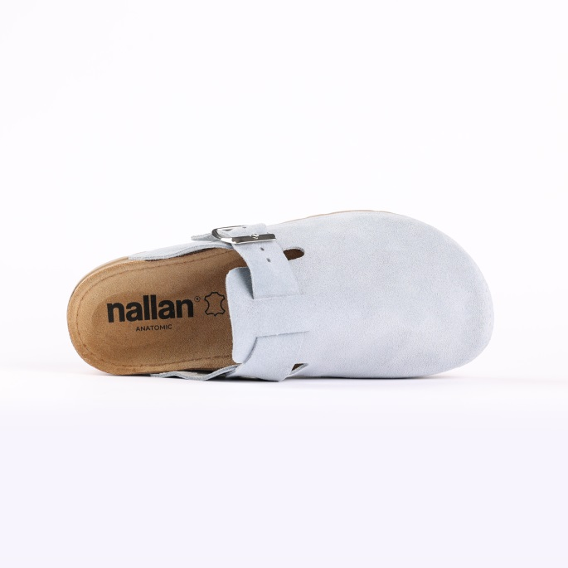
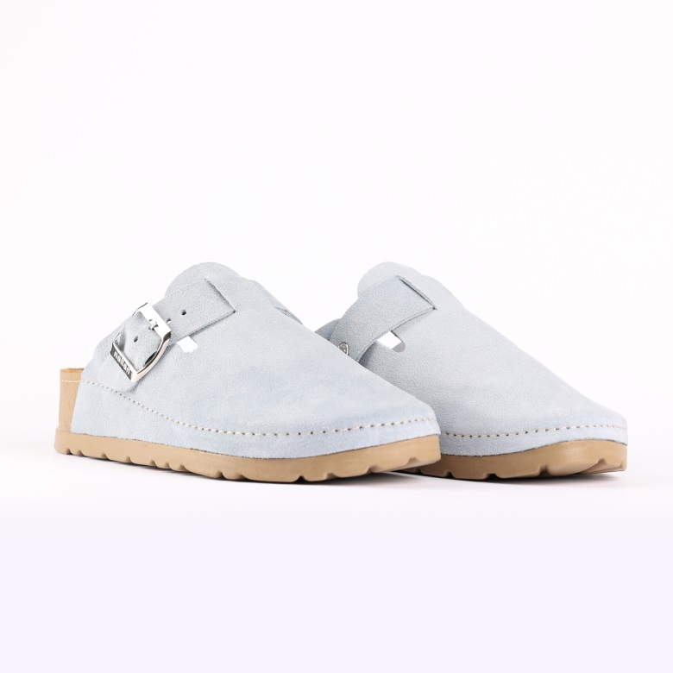
SLIPPERS – NEXA- LIGHT GRAY

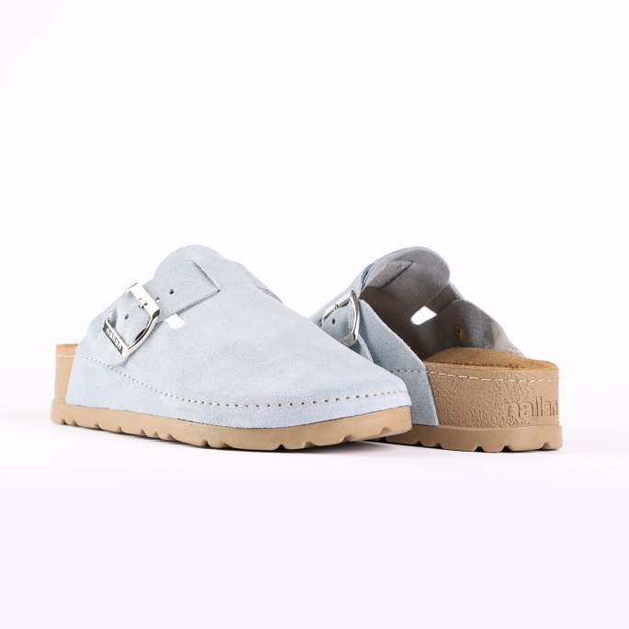
SIZE: 36-42 41-46
44
4

- Code: N355-1V071LGRY
Upper : Velour
Lining : Leather Sole : PU (Polyurethane) Accessories : Yes Heel Type : Anatomic

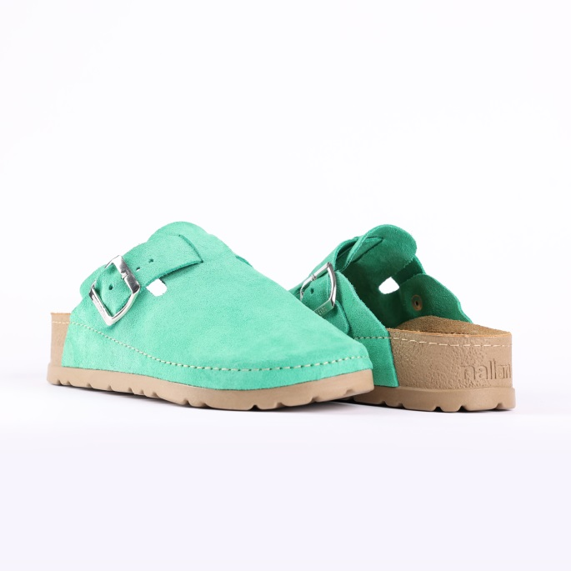
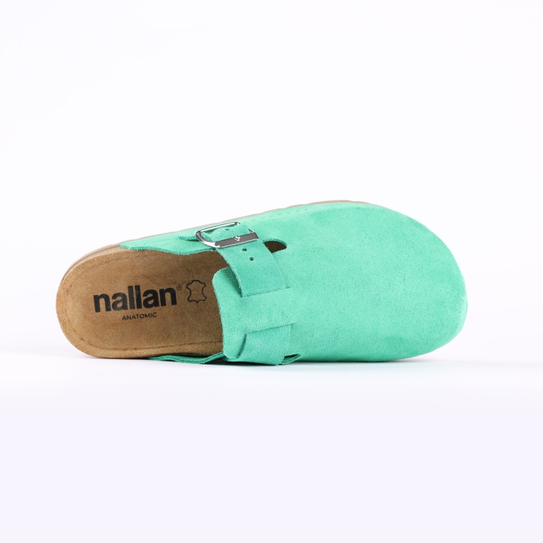
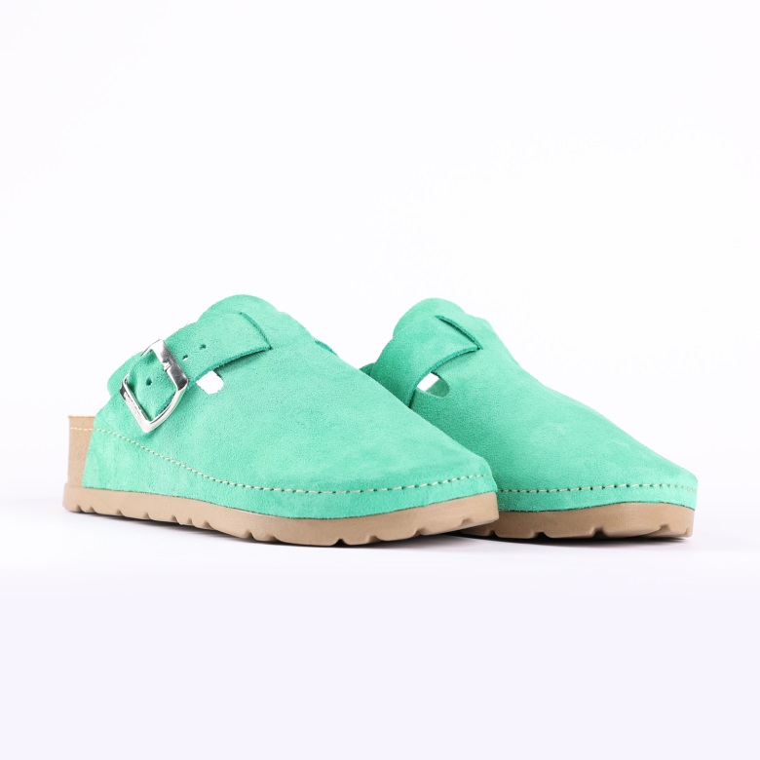
SLIPPERS – NEXA- CLEAN GREEN

- Code: N355-1V071CGRE
Upper : Velour
Lining : Leather Sole : PU (Polyurethane) Accessories : Yes Heel Type : Anatomic

SIZE:37-42

SIZE: 36-42 41-46
44
4

SLIPPERS – NEXA- YELLOW

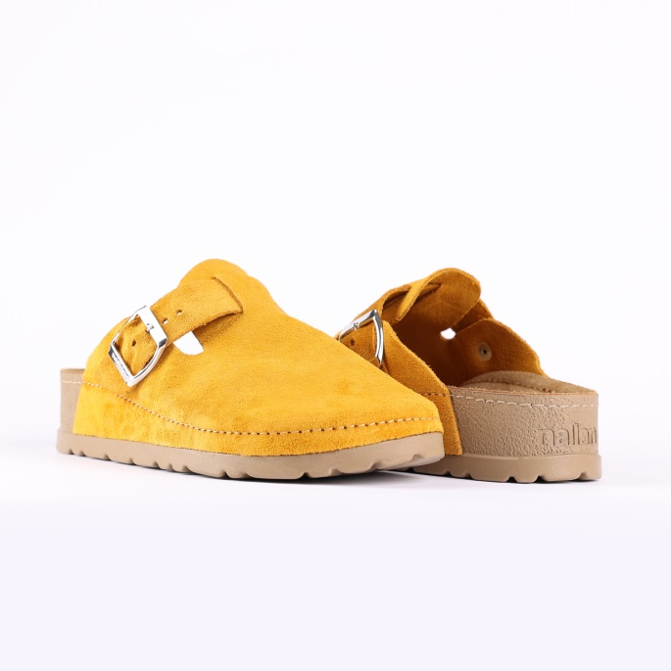
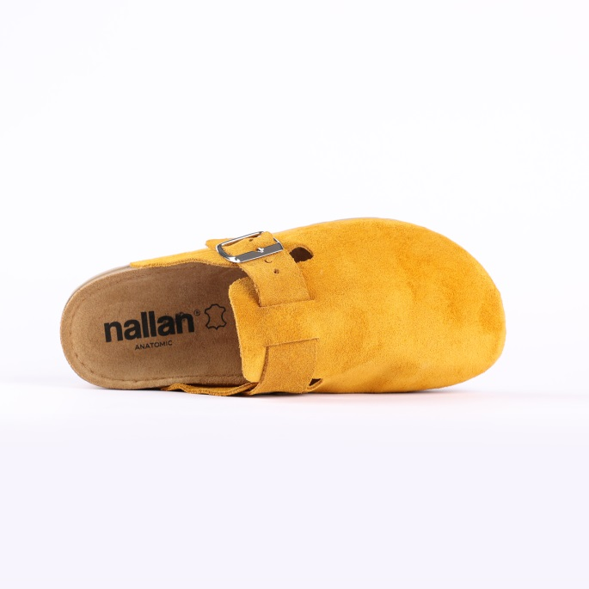
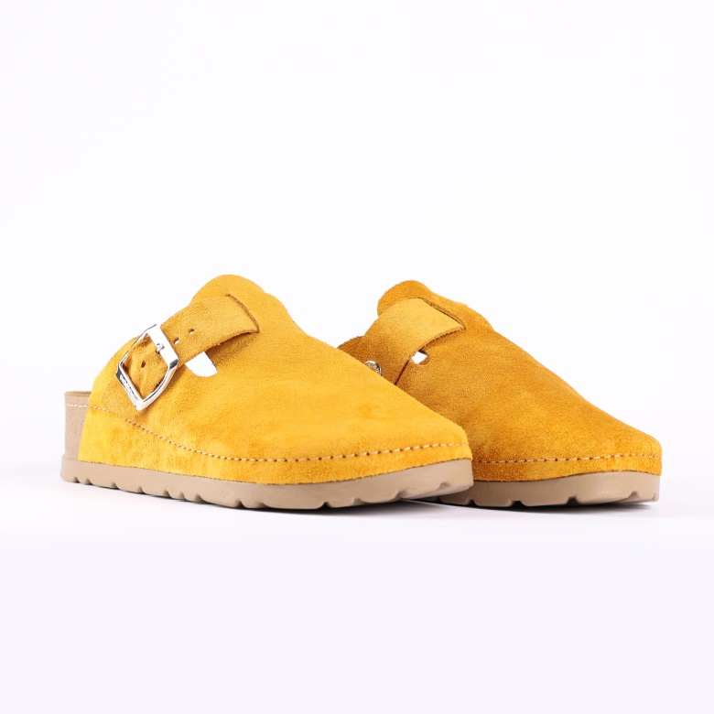
SIZE: 36-42 41-46
44
4

- Code: N355-1V071YELL
Upper : Velour
Lining : Leather Sole : PU (Polyurethane) Accessories : Yes Heel Type : Anatomic

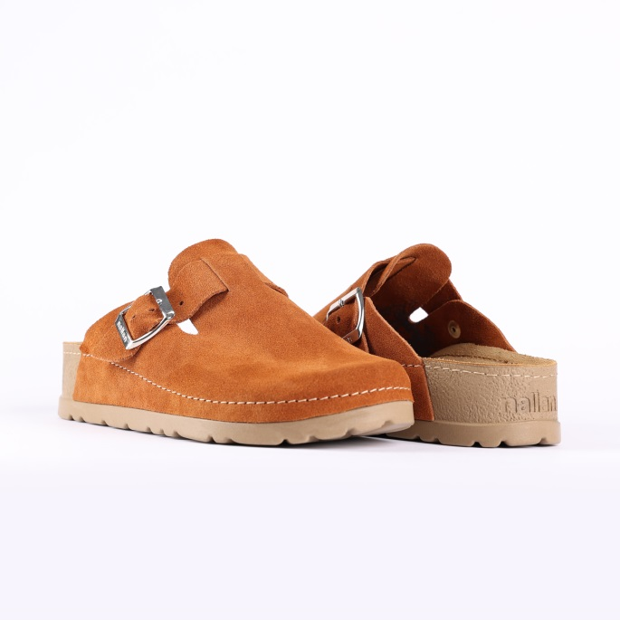
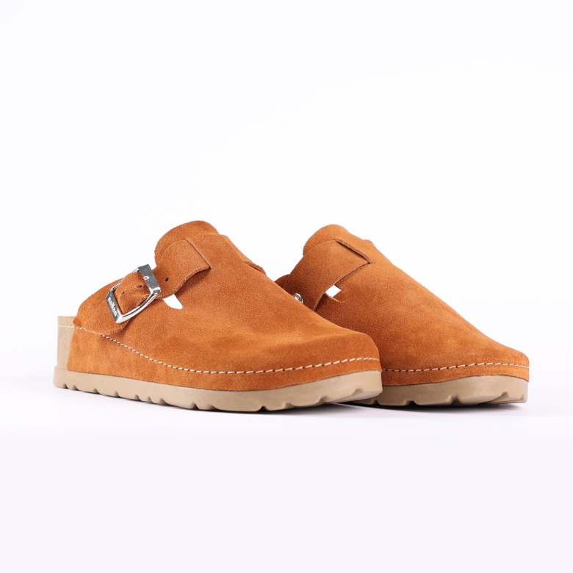
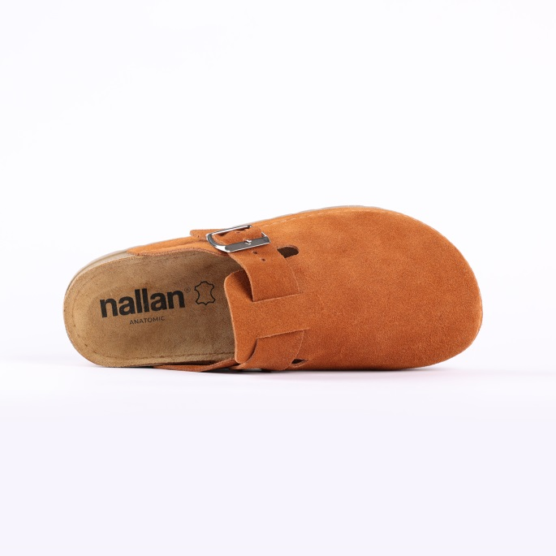
SIZE: 36-42 41-46
44
4

- Code: N355-1V071CARM
Upper : Velour
Lining : Leather Sole : PU (Polyurethane) Accessories : Yes Heel Type : Anatomic

SLIPPERS – NEXA- CARAMEL

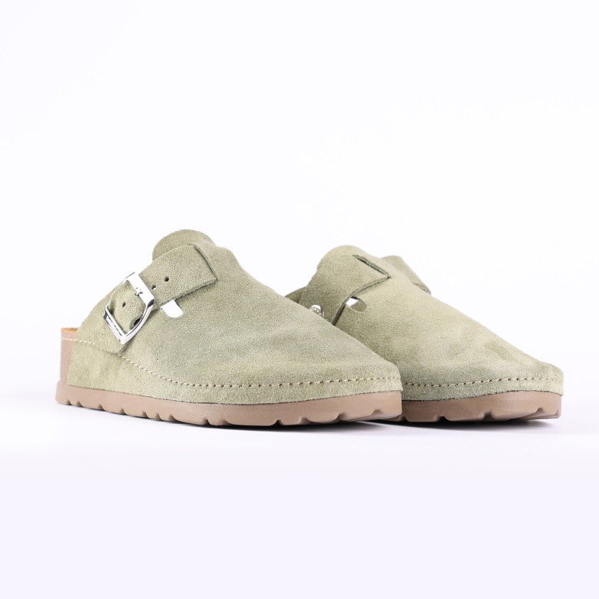
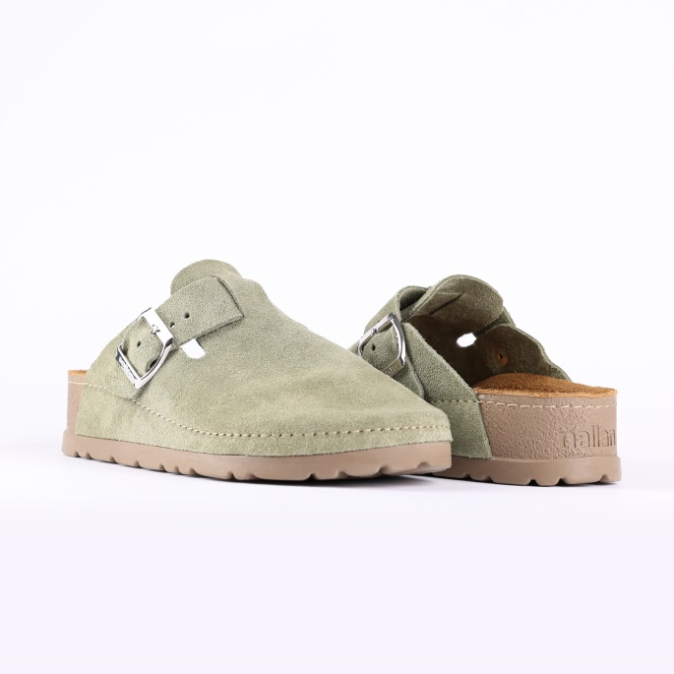
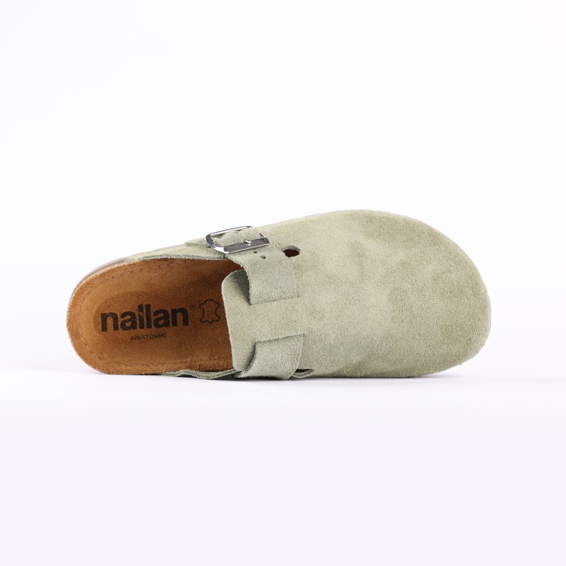
SIZE: 36-42 41-46
44
4

SLIPPERS – NEXA- BLAND

- Code: N355-1V071BLAN
Upper : Velour
Lining : Leather Sole : PU (Polyurethane) Accessories : Yes Heel Type : Anatomic

Upper - Leather
Lining -Leather
Midsole - PU(polyurethane)
Sole - PU(polyurethane)
Accessories - Buckle
Heel Type - Flat Anatomic

Upper - Leather
Lining -Leather
Midsole - PU(polyurethane)
Sole - PU(polyurethane)
Accessories - Buckle
Heel Type - Flat Anatomic

Upper - Leather
Lining -Leather
Midsole - PU(polyurethane)
Sole - PU(polyurethane)
Accessories - Buckle
Heel Type - Flat Anatomic

Upper - Leather
Lining -Leather
Midsole - PU(polyurethane)
Sole - PU(polyurethane)
Accessories - Buckle
Heel Type - Flat Anatomic

Upper - Leather
Lining -Leather
Midsole - PU(polyurethane)
Sole - PU(polyurethane)
Accessories - Buckle
Heel Type - Flat Anatomic

Upper - Leather
Lining -Leather
Midsole - PU(polyurethane)
Sole - PU(polyurethane)
Accessories - Buckle
Heel Type - Flat Anatomic

Upper - Leather
Lining -Leather
Midsole - PU(polyurethane)
Sole - PU(polyurethane)
Accessories - Buckle
Heel Type - Flat Anatomic

Upper - Leather
Lining -Leather
Midsole - PU(polyurethane)
Sole - PU(polyurethane)
Accessories - Buckle
Heel Type - Flat Anatomic

Upper - Leather
Lining -Leather
Midsole - PU(polyurethane)
Sole - PU(polyurethane)
Accessories - Buckle
Heel Type - Flat Anatomic

Upper - Leather
Lining -Leather
Midsole - PU(polyurethane)
Sole - PU(polyurethane)
Accessories - Buckle
Heel Type - Flat Anatomic

Upper - Leather
Lining -Leather
Midsole - PU(polyurethane)
Sole - PU(polyurethane)
Accessories - Buckle
Heel Type - Flat Anatomic

Upper - Leather
Lining -Leather
Midsole - PU(polyurethane)
Sole - PU(polyurethane)
Accessories - Buckle
Heel Type - Flat Anatomic
